Daily Documentation:

Day 1: Made the basic character controller. It loops across the screen and moves how I want it to

Day 2: Made the game more visually appealing. Gave it a parallax background.

Day 3: Made a basic randomly moving enemy using the same player controller. This will be the basis for my other enemies

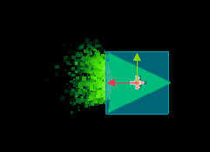

Day 4: Made the enemies change every x seconds. Will make a lore reason later.

Day 5: Players can shoot. They interact with the enemies as well. Enemies getting shot explode and drop a random power up some percent of the time (will change)

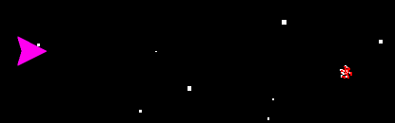

Day 6: Added one extra enemy. Made player flash when invincible. Fixed audio mixing. Wrote lore. Added lives system. Display lives and score.

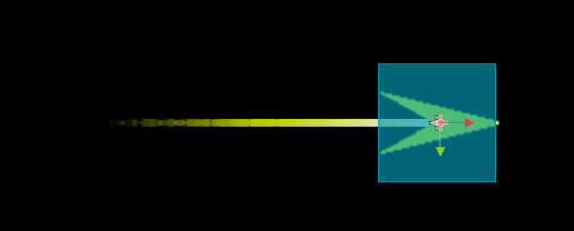

RESOURCES USED:

Music from #Uppbeat:

https://uppbeat.io/t/danijel-zambo/stardust

License code: SASM0SR67K4DX6OI

<https://mixkit.co/free-sound-effects/game-over/> (“Arcade Game Over”)